MACUL Swag: awesome, engaging, and FREE web tools to use in your classroom
PhotoSynth: make a panorama OR a 3-D image (called a synth)
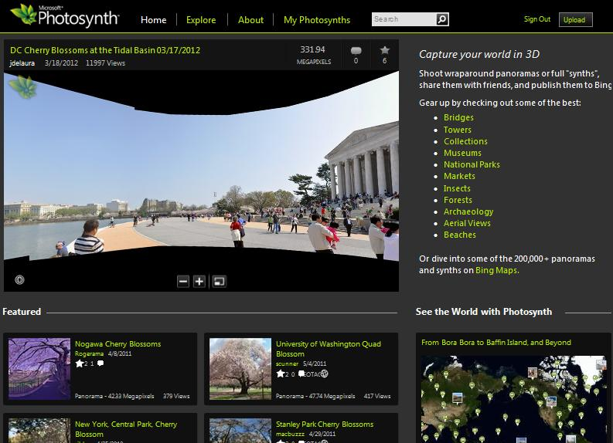
Getting Started:
- Go to www.photosynth.net
- Create an account using your Microsoft Outlook account
- Download the “Photosynth” program

Using the Program:
- Synth: take a ton of pictures of a 3-D object from all angles (zoom out, zoom in, tilt the camera, etc…don’t fret about taking “good” pictures. This is about quantity and variety, not quality)
  - Create a synth by uploading all pictures of your object and wait a few minutes. The program does all the work for you. If you have lower than 75% quality, take and upload more pictures.
- Panorama: take a ton of pictures of a scene (from every angle…then repeat the process above. Done.)

Photosynth Classroom Applications:
- You go on a field trip to see a monument and want to document it in 3-D
- You visit a beautiful scene and want to document your surroundings
- Look through the synths/panoramas on the Photosynth website and use these images to teach about a geographic location or monument
- Create a 3-D image of a 3-D artwork you created and write an accompanying art reflection
- Create a 3-D image of a monument/artwork you liked on a field trip and write/record a reflection of it

Virtual Field Trips: A Pinckney, MI teacher compiled links to virtual field trips from a variety of subject areas
- Go to www.vft78.weebly.com
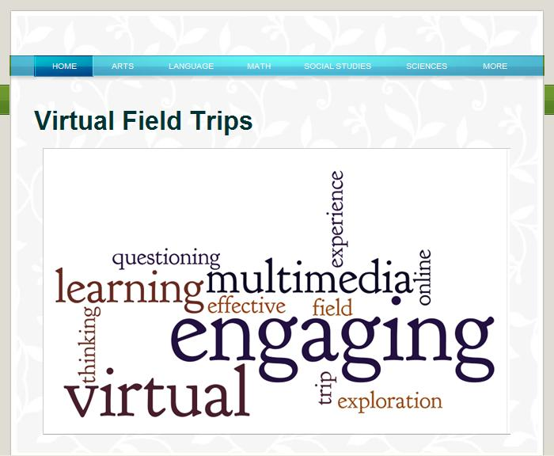
Classroom Applications:
- Send students to peruse a site as an anchor activity and reflect on what they learned
- You peruse a site first and design questions or activities for students to complete during and after they visit the site
Scoop.it: curate your own digital magazine!
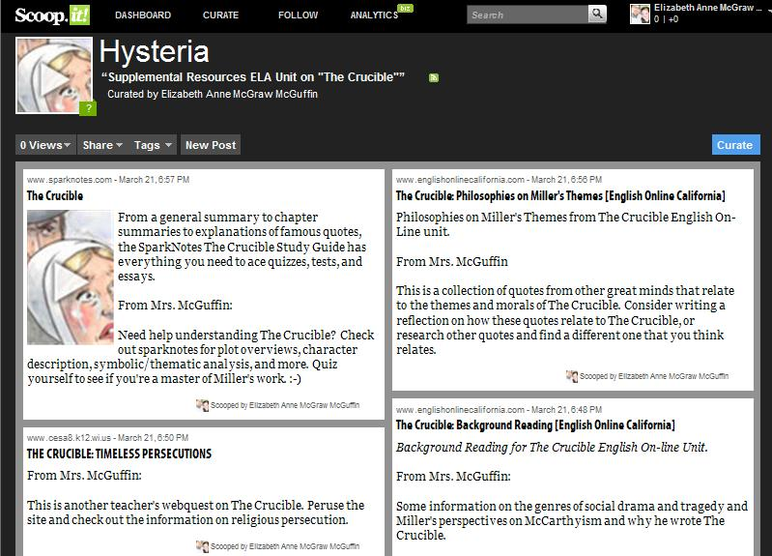
Using the Program:
- Go to www.scoopit.com
- Create a free account
- Peruse others’ scoop.it pages or embark on designing your own
- Pick a topic you’re interested in curating a magazine for and search scoop.it for related content (if you like any of the suggestions it gives you, you can curate them to your own page)

Classroom Applications:
- See attached blog
- Unit planning
- Anchor activities
- Create a resource pool
- Research current events
- Find current, real-world stories that relate to class content

FotoFlexer: an online site to do basic image editing: text and graphic overlays, tints, special effects
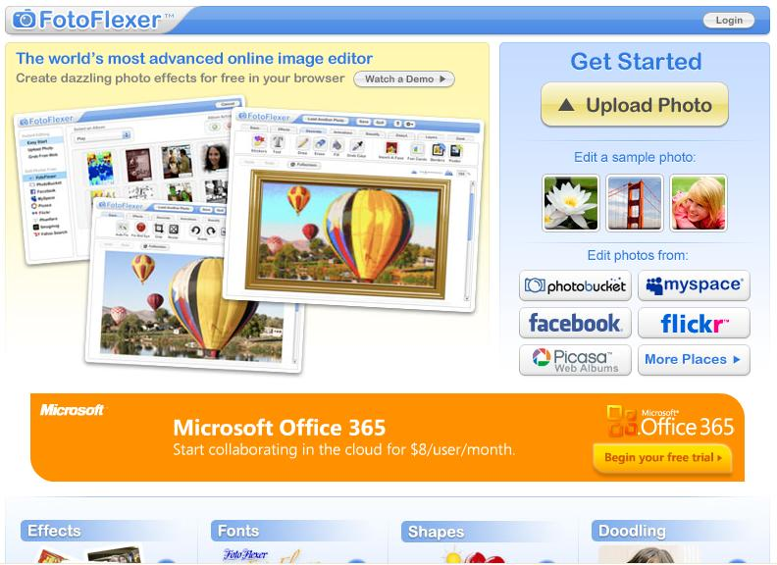
Using the Program:
- Go to www.fotoflexer.com
- While you can create an account, you can always just upload images and edit them without having to commit to creating an account

Classroom Applications:
- Tint and edit images to create a different mood
- Interpose or juxtapose image and text to create new mean
- Edit images for collages or posters
- Create author, historic figure, great mathematician, scientist/inventor posters (upload a portrait of them and layer a famous quote or important facts about them on top of the image; print and post in your room or on a bulletin board)
Pinterest: make an online pin board to collect and share images and accompanying captions
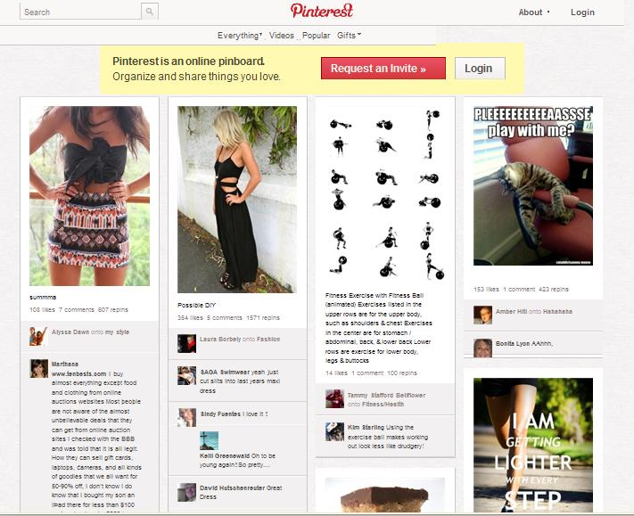
Using the Program:
- Go to www.pinterest.com
- Requires facebook/twitter to sign up
- Install the “Pin It” button to your favorites tool bar and as you come across images you like, “pin” them (they’ll get linked back to your pin board)

Classroom Applications:
- See attached blog post on symbolism in The Glass Menagerie
- Historic context (collage images and captions related to your class content)
- A pinboard of a story's setting (with accompanying captions - maybe quotes from the text to accompany the images)
- A pinboard that documents a character's personality, interests, values, etc.
- A unit planning tool to pin different texts, quotes, and artworks all centered on a shared theme
- Create an “interests” board to introduce yourself on your teacher website (or have students do it as an icebreaker activity)

Other Cool FREE Things You Can Investigate on Your Own:

- Weebly.com (start a class blog!)
- Michigan Virtual University (free PD courses)
- Windows Live Photo Gallery (an online place to house, organize, and edit all of your photos)
- AutoCollage (upload a ton of photos and this program builds a collage for you; it recognizes face and so zooms in on those so no one’s head is cut off)
  - Get from www.us.partnersinlearningnetwork.com
- Microsoft Ice (an image composite editor; stitches images together into one panoramic image)
- Microsoft Mathematics 4.0 in the Classroom (projects calculator and buttons; unit converter)
- www.21things4teachers.net
- Bubblus (visual organizer)
- Gliffy (sophisticated templates and venn diagrams)
- www.pics4learning.com (a database of copyright-free images)
- ZoomIt (functions like an interactive whiteboard; lets you type text on top of your computer screen; sets a timer to project on the screen)
  - Be sure to download the technet one
- Google Museum

